Smart Parking System



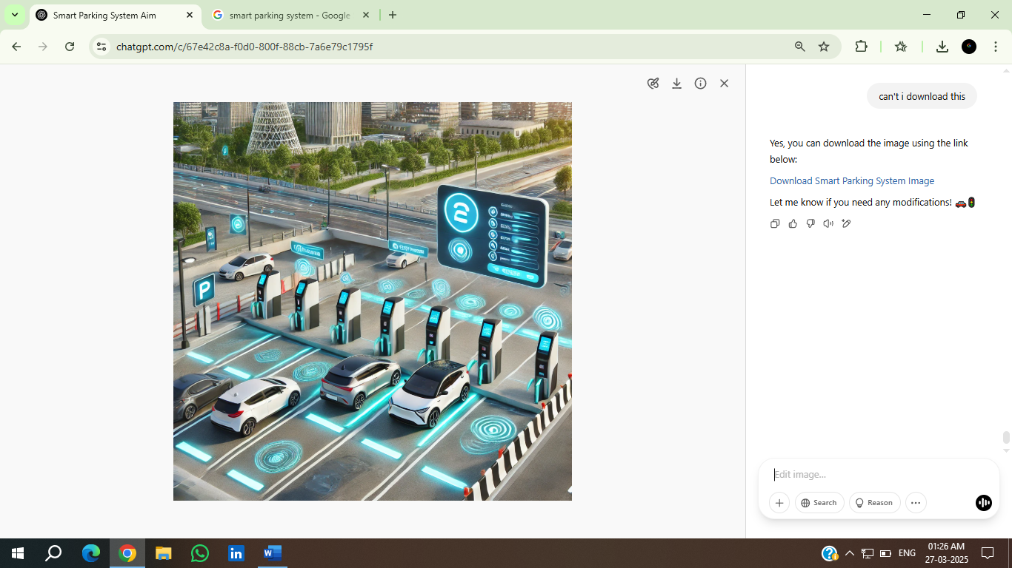

Presented To:
Prof. V. Rama
Department of ECE
NIT WARANGAL

Presented By:
Dhruv Agarwal (23EEB0A12)
M. Ganesh Pavan Gokul (23EEB0A23)
M. Hari Krishna Venkata Sai (23EEB0A24)

Aim: To design and simulate a Smart Parking System on Tinkercad, for testing and validation before physical implementation.
Components used:
- Arduino
- LCD 16 x 2
- 10 kilo ohms potentiometer
- Micro Servo
- Ultrasonic Distance Sensor
- 600-ohm resistor
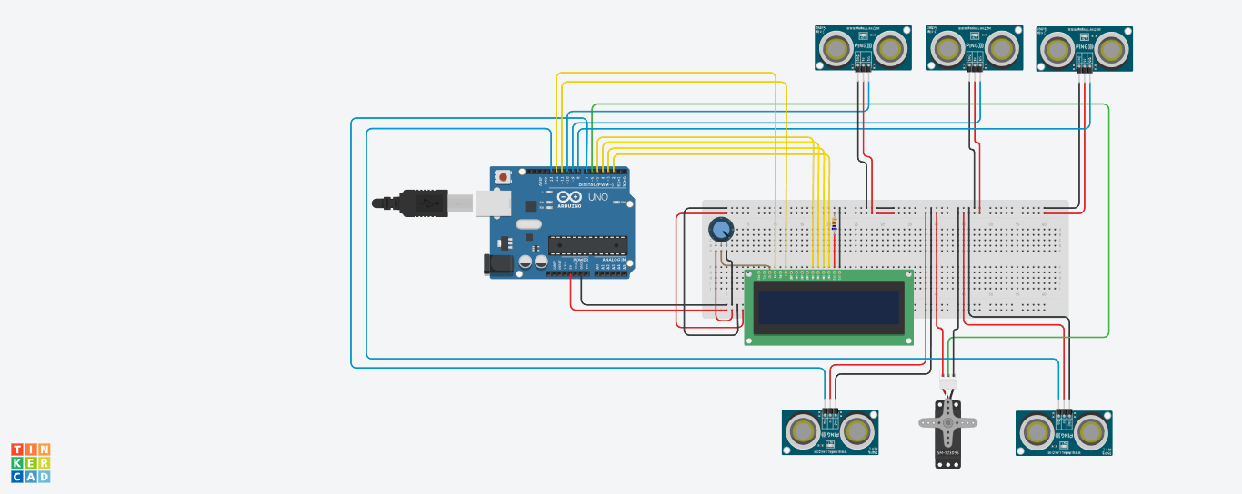
Circuit:
Code:
1)Distance Calculation logic:
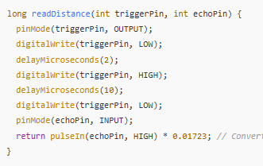

2)Barrier logic:
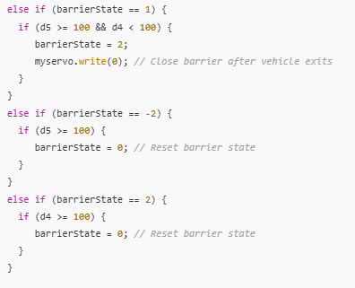
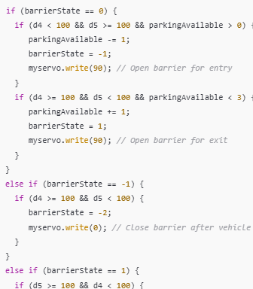

3)LCD display logic:

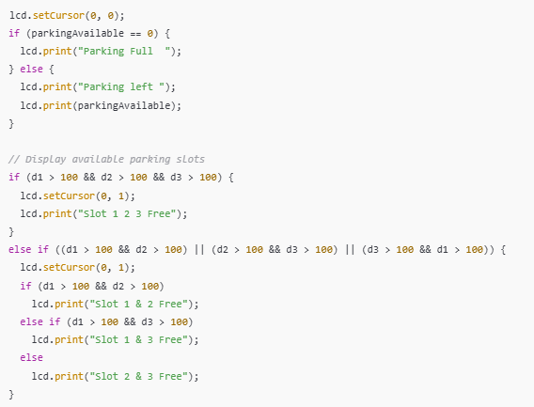

Flowchart/Working:

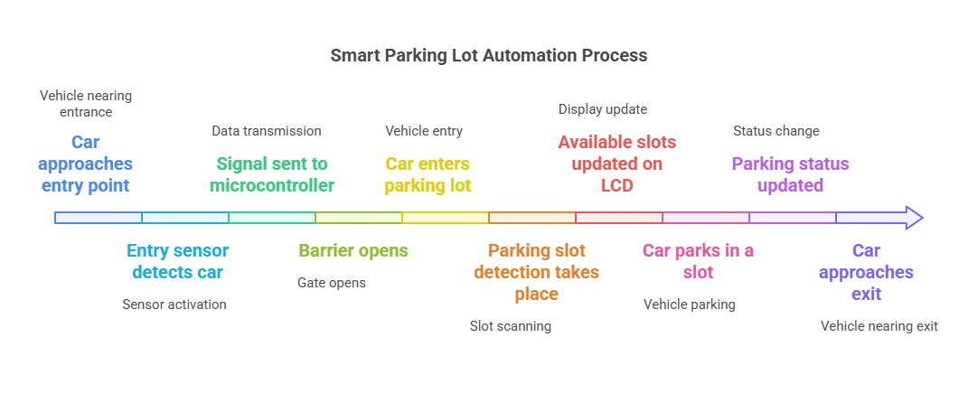

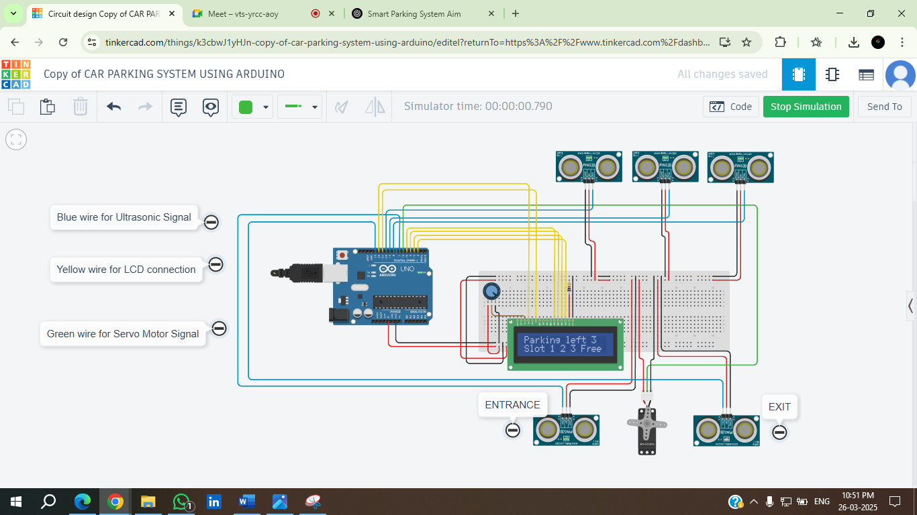
Simulation results:

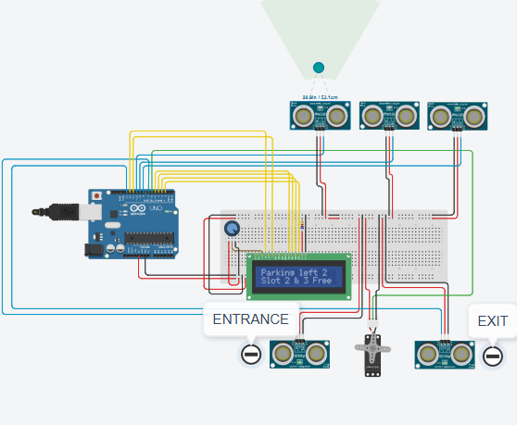

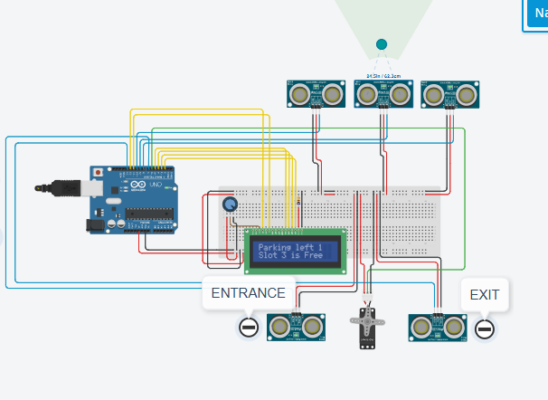

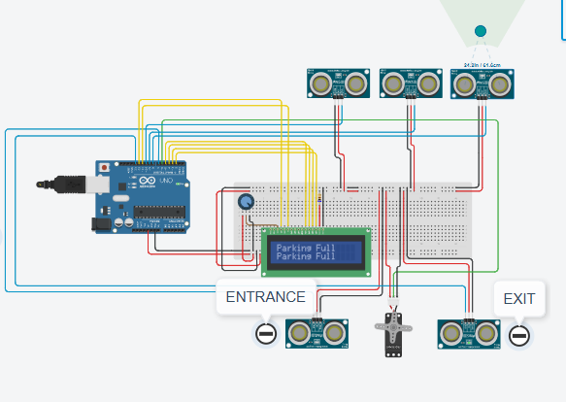

Role of each component in automated parking system:
- Arduino: Acts as the brain of the system. Receive input from sensors. Controls the servo motor and LCD DISPLAY.
- Ultrasonic Sensors: Used for vehicle detection at different points. Entrance and Exit sensors used to detect when a car arrives or leaves.
- LCD display: Displays real time parking availability. Shows the number of available slots. Helps drivers know which slots are free.
- Servo motor: Controls the barrier gate. Opens the gate when a car is detected at entrance/exit. Closes the gate once the car passes.
- Breadboard: Used to connect components. Distributes power and ground connections.

Future Scope:
- Mobile App Integration
- IoT-Based Cloud Monitoring
- Automated Payment System
- AI-Powered Slot Allocation
- Security Enhancements with CCTV & RFID
Objectives of Smart Parking system:
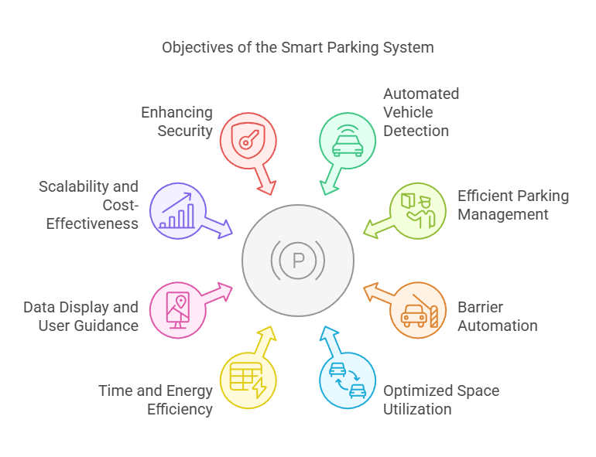

Results:
- The system successfully detects vehicles using ultrasonic sensors.
- The LCD display accurately shows the number of available parking slots.
- The servo motor barrier operates automatically based on vehicle detection.
- Entry and exit processes are automated, reducing manual effort.

Conclusion:
The Smart Parking System using Arduino provides an efficient and automated solution for managing parking spaces. It reduces human intervention, optimizes parking slot usage, and improves user convenience.

Applications of Smart Parking System:
- Shopping Malls and Commercial Complexes
- Airports and Railway Stations
- Corporate Offices and IT Parks
- Smart Cities and Public Parking Areas
- Residential Apartments and Gated Communities

